Alumnus connect – Hari Ganesh

Hari Ganesh is an alumnus of Computer Science and Engineering in SSN from the 2010 batch. Originally from Salem, Hari has gone on to complete his postgraduate master's degree at Stanford, enjoyed a successful 2 year stint with the Boston Consulting Group and is currently pursuing his MBA at Harvard Business School and his Masters in Public Policy at Harvard Kennedy School. Lakshya was thrilled to bring back an alumnus such as Hari Ganesh, who was so widely travelled and had many wonderful achievements to his credit.

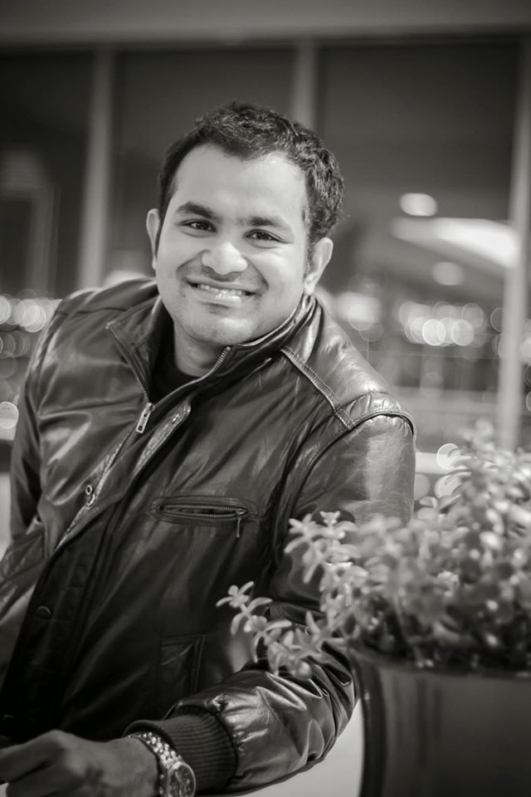

Phase 1: SSN College of Engineering

Any institution’s success can be determined by a myriad of factors, of which the most important is the position of the alumni and the trajectory provided to them after their alma mater. A good alumni network brings credibility and strength to an institution’s reputation. One such prodigal product of the system is Hari Ganesh, who visited SSN on the 24th of June, 2015 to a packed mini auditorium to speak about his experiences and exciting career path.

Hari’s talk was the perfect pipeline in terms of advocating possible avenues to consider in order to effectively reach the destination from the point of start. Largely focused on managerial education, Hari delved into possible programs and specialisations abroad while touching upon post MBA career paths.

Hari’s journey after SSN captivated the audience’s mind in general. He provided a short insight into management consulting and guided the riveted students through his travails. One of the highlights of his talk was when he brought about the changing trends of competitive exams like the GMAT and the nuances of managerial education.

The session then moved towards a highly interactive exchange of thoughts and experiences where Hari attempted to answer queries and inspire the students to find what they were looking for.

The best part about this talk was the connect that every student felt, owing simply to the fact that Hari was someone who had gone through the same set of experiences as part of his undergraduation before his subsequent choice of career.

Phase 2 – ITC Grand Chola

Roughly six months after the initial talk, Lakshya developed an interesting structure for phase two of the alumnus connect with Hari Ganesh.

This event employed an interesting mechanism to filter out a select set of candidates to attend the exclusive dinner. A questionnaire which revolved around and tested the applicant’s idea of management, their plan or interest in a management degree in the future and the steps they had taken in order to pursue said degree and the planned trajectory towards their respective goals, was prepared. Additionally, the applicants were also encouraged to send in a short video on why they felt they should be a part of the event.

From among numerous applications scrutinized by Hari himself, four worthy candidates were picked and invited to attend the dinner with Hari Ganesh along with a few representatives from Lakshya. This was their window to management studies and networking at the highest level.

The session proved to be highly productive and enlightening for all the participants, fuelled by Hari narrating some wonderful experiences and paving way to an intellectual discussion on a diverse range of topics.

Hari brought about the various differences in the education systems between India and the USA. He spoke about opportunity costs, value of certain programs, risks associated, campus life, career paths, his vast foray of connections, his passion, about people, different cultures, etc.

Hari also spoke about the perks and perils of consulting and dispelled common misconceptions. He shed light on some interesting travel experiences while constantly reminding the participants of the need to bring out their originality and to remain intrinsically proactive.

Ultimately, it concluded as an unforgettable night for every single participant with a lot more than career guidance to take back, having been inspired and stimulated, both academically and psychologically.